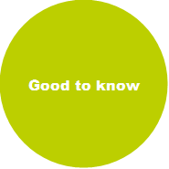
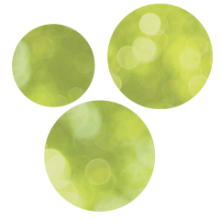

Good to know about Finns and Finland:

Our characteristics, society and school:
Finns are very polite and honest, but most of us are a bit shy, which might come across as being impolite. Patience, we will warm up surely but slowly!
Small talk is not our strength, silence is considered ok 😉
Finns avoid arguments / debates and are used to making compromises. They think that everyone is entitled to their opinion.
Finns like to keep things simple. They are good in summarizing what to say into 1–2 sentences 😀. We like to work effectively, leaning on common sense and trust. Teachers, and employees in general, have a lot of autonomy in their work. There is not a lot of bureaucracy nor hierarchy, and we trust the society. Everyone calls each other by their first name in working life. Also, students call their teachers by their first names.
People living in Finland have equal opportunities to succeed in life. Schools and universities are free of charge, and free, healthy lunch is served from 1st grade till the end of vocational school or high school. Society takes care of everyone, we pay high taxes but get a lot of services in return, e.g. schooling and public healthcare.
Students study in the nearest school from their home from 1st grade to 9th grade. No matter what grades they get on exams or what their background is, they are all equal in the classroom. There are no levels that define their future study career.
In the education system there are no dead ends. You can study a university degree also after a vocational basic qualification, if you have the motivation and skills for it later in your life. It is not rare to study a vocational qualification after a degree in a university or university of applied sciences, either. It is common to change your profession during your life and study as an adult. The government supports also adult studies with student grants. 70 % of Keuda´s students are adults. We value continuous learning.

General:
Finland is a very safe country. Our tab water is one of the cleanest in the world. We take sustainability and recycling seriously.
It is always a good time to have a coffee break, Finnish people are the world’s biggest coffee and ice cream consumers.
Finland has been named the happiest country in the world many times over 😊 some say it might be because of the dark winter season – we have learnt to take it easier then, and to relax and sleep 😊
We have over 4 million saunas in Finland and 188 000 lakes. Note: Population in Finland is 5,5 million.
In Finland we are very punctual, better early than late.
When going to someone’s home you take your shoes off at the door, to help keep the house clean. Women in general all have a professional career and go to work! Part time work is still rare.
There is only couple of hours of sun in wintertime, and a couple of hours darkness in summertime due to our Northern location.

Mealtimes:
Typical breakfast is salty, a sandwich/toast or oatmeal porridge. For lunch we have a warm meal, as well as for dinner. Evening snacks are often also a sandwich or a yoghurt. Coffee breaks are usually in the morning around 9.00 am and in the afternoon around 14.00 pm.
- Breakfast 6–8.00
- Lunch 10.30–13.00
- Afternoon coffee/snack 14–15.00
- Dinner 17.00
- Evening snack 20.00

Must things to do and try in Finland
Try this:
- Fazer chocolate
- Salmiakki (salty liquirice)
- Cinnamon rolls
- Carelian pies (Karjalanpiirakka)
See this in Helsinki / capital area
- Senate Square
- Suomenlinna Sea fortress
- Löyly or Allas Sea Pool (sauna and outdoor swimming in Helsinki, also a restaurant)
- Temppeliaukio Church (”Rock Church”)
- Ateneum Art Museo (Finnish art)
- Oodi Helsinki Central Library, a great new wooden building to visit Home - Oodi (oodihelsinki.fi)

Skate rentals during the winter:
- Hotel Gustavelund, the address is Kirkkotie 36, and you can rent the skates every day from 10 to 18. https://www.gustavelund.fi/tapahtumat/703/retkiluistimet-varusteineen-gustavelundista

- Tuusulanjärvi, Järvenpää. The rental point is open 24/7 and it is located at Järvenpää Rantapuisto, Aeto Garden. https://helsinginretkiluistelu.fi/en_US/retkiluistelijan-vuokravalineet/itsepalveluvuokraamo-jarvenpaa

If you have more time:
- Haltia Nature Center in Espoo, in the National Park Nuuksio with hiking trails Haltia - Finnish Nature Centre Haltia - haltia.com
- Halosenniemi -museum in Tuusula, an impressive home museum of painter Pekka Halonen Halosenniemi Museum - Visit Tuusulanjärvi (visittuusulanjarvi.fi)

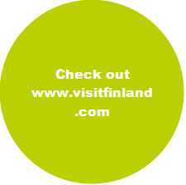

WARM WELCOME TO KEUDA AND TO FINLAND!

